**DSO 545 – Final Project**

Executive Summary:

Our purpose is to understand LA 311 data trends in order to identify potential areas to improve 311 services. We will examine the overarching trends and will recommend actionable strategies based on the insights gathered. We organized out findings in analyzing 1) who are the users of the App, 2) where is the demand for services, 3) How is the city’s response, and 4) Recommendations based on the data.

1. **Who are our users**:
   1. Trends in Mobile OS

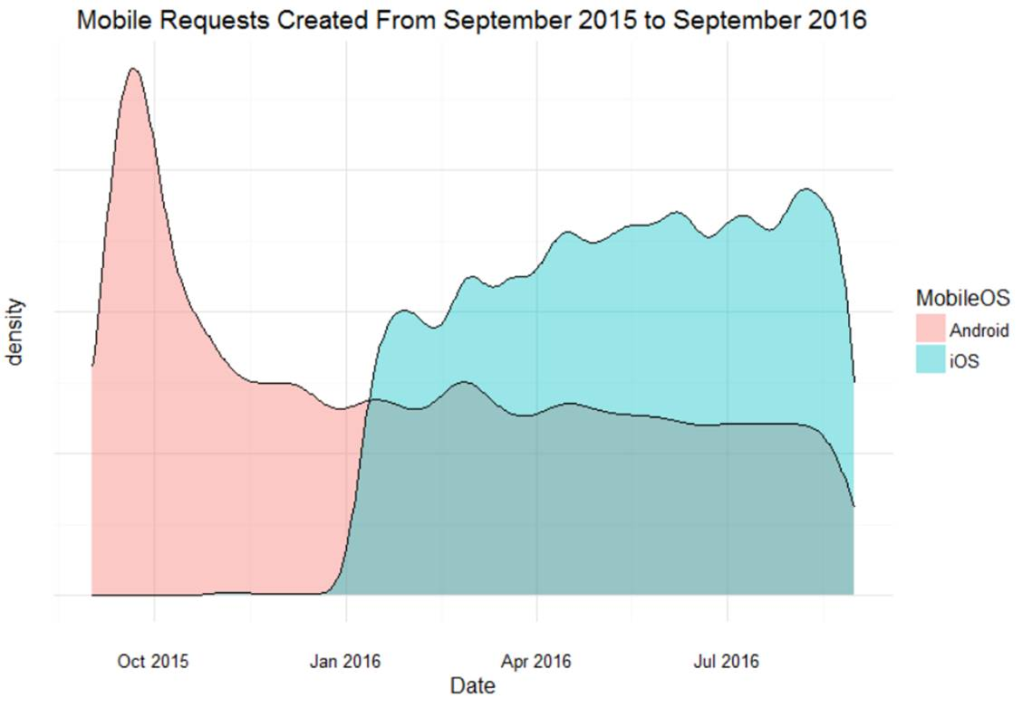

Insights - from Sep. 2015 to Sep. 2016:

A big spike of requests on Android were made during the month of October 2015 – possibly correlated to social media promotion events.

iOS App seemed to be new and only started activity around January 2016 – most likely when the app was launched for iOS users.

Since the entrance of iOS to the game, more requests were made via Apple than Android phones.

* 1. 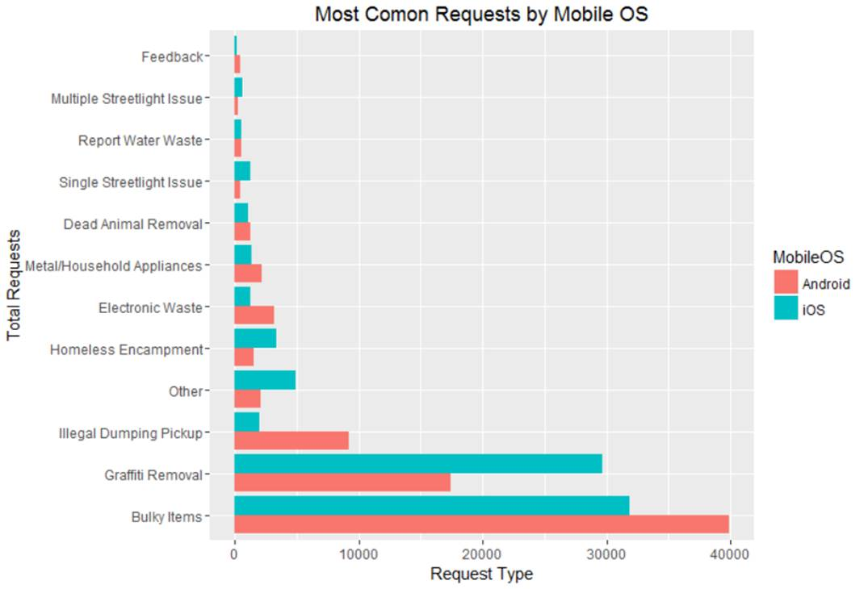Service Request by OS

Insights – Requests made by the different mobile apps:

Most requested by Android (in descending order): Bulky Items, Graffiti Removal, and Illegal Dumping Pickup

Most requested by iOS (in descending order): Bulky Items, Graffiti Removal, and Other

Significantly more iOS users report graffiti removal.

* 1. Request differences by OS

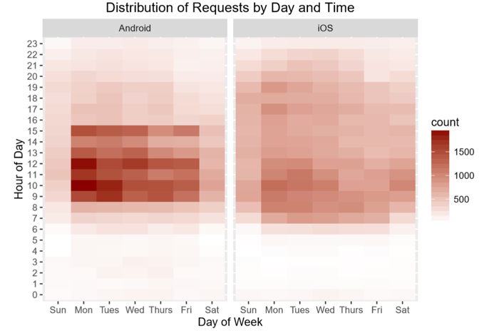 Insights - Requests by Time and Date per OS

Most requests were made with Android phones.

Monday is a highly busy day – More calls are made in the beginning of the week.

Most requests are made between 8AM and 3PM.

iOS calls go until later hours than Android – up to 9PM

Barely any requests are made from midnight to 6 AM

1. **Where is the demand:** 
   1. 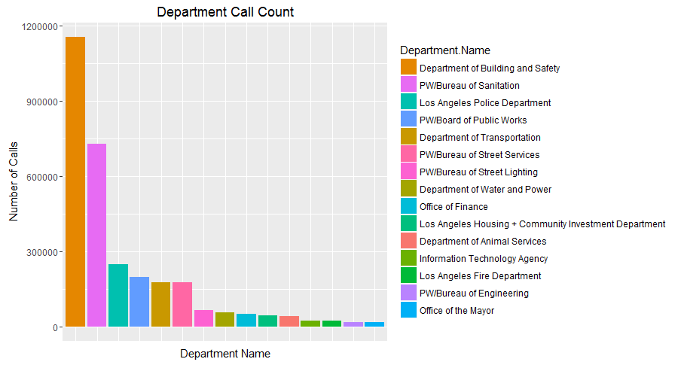Analysis by Department

Insights - Top 15 departments based on call count:

* Highest number of call center calls are being handled by Department of Building and Safety followed by PW/Bureau of Sanitation

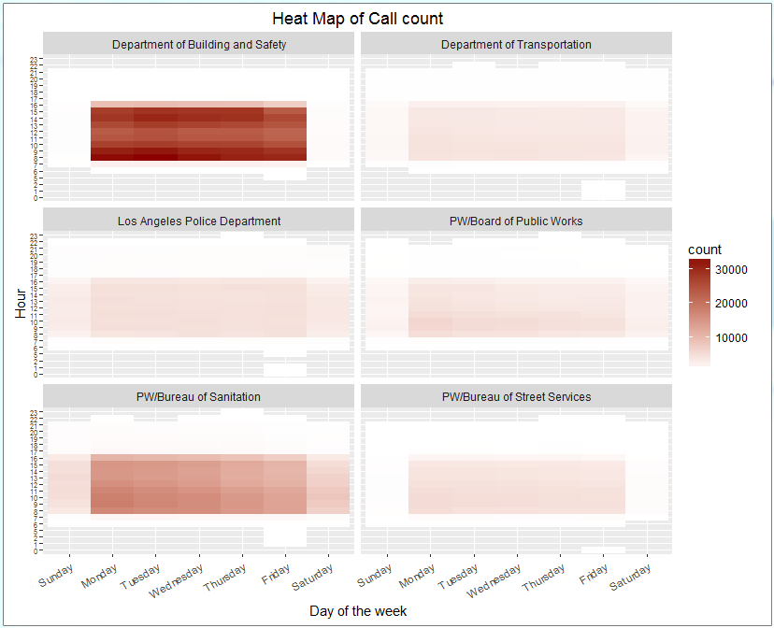 Insights - Analysis of Top 6 departments:

* Department of Building and Safety has most of the calls coming during weekdays, whereas Department of Transportation, LA police Department and PW/Board of Public Works do not have a very significant difference in number of calls coming during weekdays and weekends
* PW/Bureau of Street services get negligible calls during weekends

(Recommendation related to Work Force distribution for each day

* 1. Services Requested

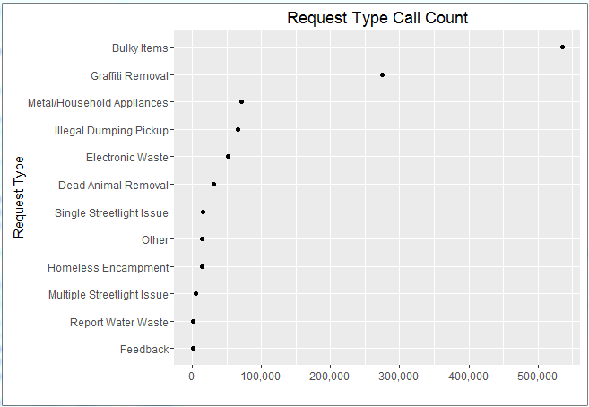Insights - Distribution of Request Type (Exploratory analysis):

* Maximum number of requests are coming for ‘Bulky Items’ followed by ‘Graffiti Removal’
* Very few requests are coming for ‘Report Water Waste’ and ‘Feedback’
* Recommendation: More focus should be given on handling Bulky items and Graffiti removal related problem

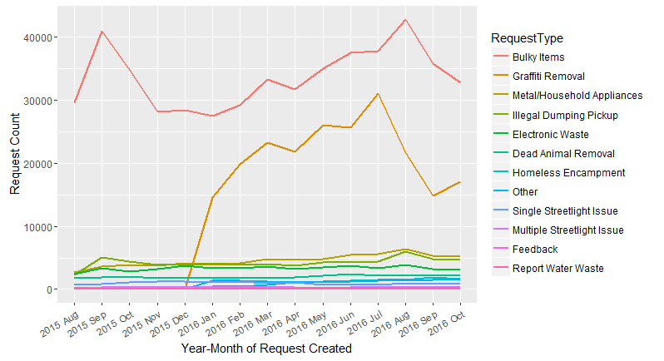Insights - Number of calls for each type of request:

* An increasing trend is observed in number of calls received for bulky items and Graffiti Removal request type
* The calls for these requests have decreased in the recent months
* This indicates that the problems related to Bulky items and Graffiti removal have started being handled with more focus
* Almost constant trend in number of requests coming for other request type is observed
  1. 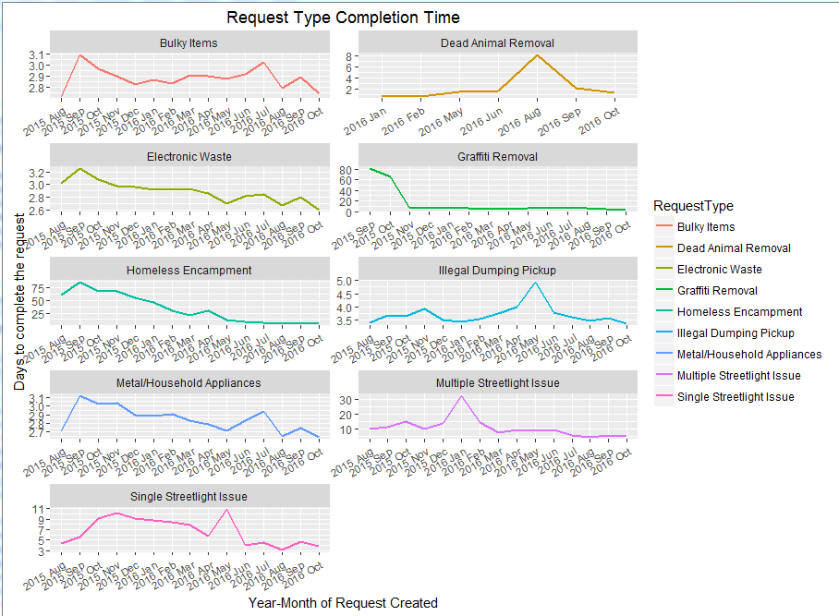Cycle Times

Insights - Trend in Cycle Time (defined as time taken to complete the request) for each request type:

* For all request types, a decreasing trend in cycle time of a request is observed indicating improvement in efficiency of handing the request

*Continued from cycle time analysis*:

* Cycle time peak is observed in
* July 2016 for Bulky Items and Metal/Household Appliances request types
* May 2016 for Illegal Dumping Pickup and Single streetlight issue
* Aug 2016 for Dead Animal Removal
* Jan 2016 for Multiple Streetlight Issue
* Above peaks indicate that these requests were not handled efficiently in that particular month
  1. Actions Taken

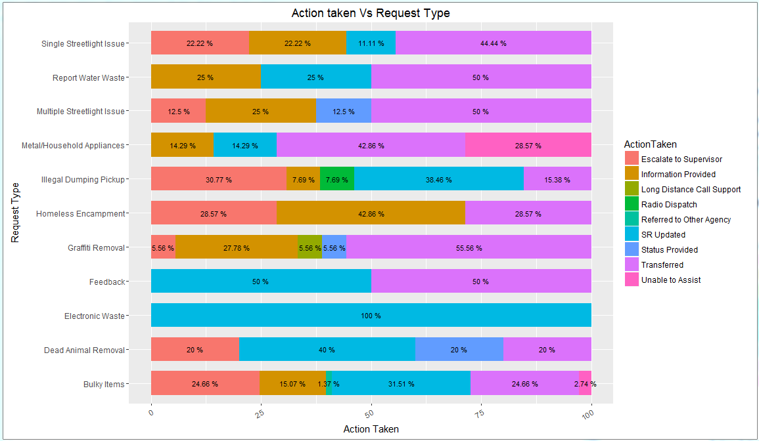Insight: Action Taken Vs Request Type:

* Action taken for each type of request type created was analyzed after removing action taken of ‘SR created’ (As it was the majority)
* More than 20% of the requests got escalated to supervisor for ‘Single street issue’, ‘Illegal dumping Pick up’, Homeless encampment’ and ‘Bulky items’
* Around 50% of requests generated for ‘Report water waste’, ‘Multiple street light issue’, ‘Graffiti removal’ were transferred to other city or department
  1. Times of demand

Insights – Demand concentration during weekdays

* Bulky Items and Graffiti Removal requests are handled throughout the week (primarily 8am-5pm)
* For all item request, nearly 80% of calls are serviced between Mon-Wed
* Majority of requests are coming of the type bulky items removal which

covers more than 90 % of the dataset. Therefore in order to analyze other request types we needed to scale them.

*Continued Time of Demand Analysis:*

* Dead Animal removal is spread across all the 5 working days during the early morning which signifies that the requests are created for the previous day or overnight requests
* Most of the Graffiti removal requests come during Tuesday and Wednesday Morning and they are primarily drivers who use self-report requests
* Single street light issues are created even during the late night time with its peak on Tuesday midnight

1. **How is our response:** 
   1. Request Types vs. Sources

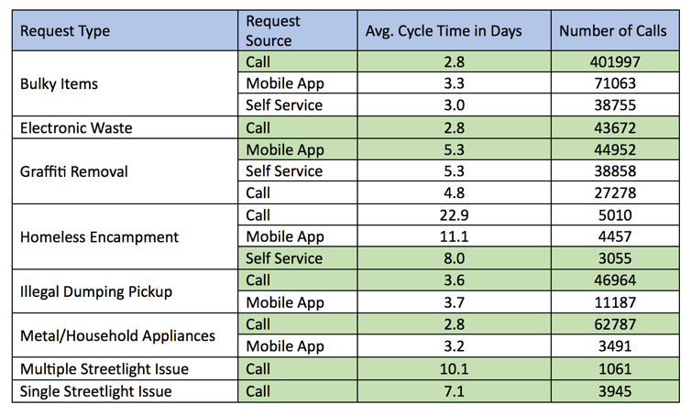

Insights - Response time varies between mobile app vs. calls

* Bulky Items are best serviced via Calls
* Graffiti removal is best serviced through the mobile app
* Homeless encampment – self-service fastest cycle time
  1. 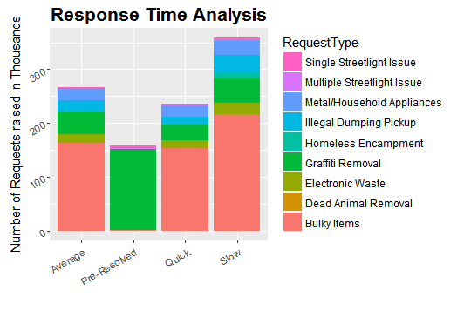Analysis of Response Times

|  |  |  |  |
| --- | --- | --- | --- |
| Response Time | CycleTime | Requests | % contribution |
| Pre-Resolved | NA | 158643 | 15.5% |
| Quick | < 1 day | 236536 | 23.2% |
| Average | < 3 days | 266663 | 26.1% |
| Slow | > 3 days | 359532 | 35.2% |

Insights – long waits for responses prevalent

* Majority of Response time are slow (greater than 3 days)
* Over 98% of pre-resolved cases are graffiti removal
  1. Awareness of the App

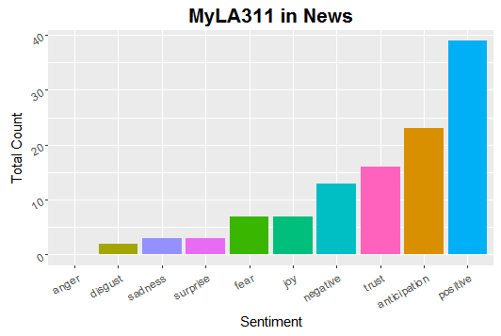Insights - MyLA 311 has been in the news 47 times at both national and international level

Sentimental analysis of all the articles on MyLA311 (google news)

Bar chart trend clearly shows a majority positive response towards MyLA311

Popularity has increased in the last year or so, with increase new reports published

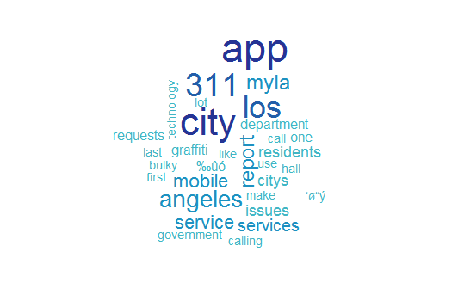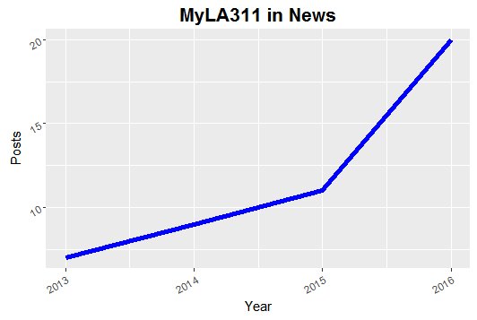 Word Cloud from Google News Reports

1. Recommendations

Based on our analysis of the LA 311 data, we focused on setting recommendations in the following areas:

* Optimize work resources for Monday through Wednesday
* Distribute requests over the weekend by increasing work shifts
  + Focus Primarily on Department of Building and Safety
* Encourage Employee Self-Reporting over public reporting
* Promote smart phone application usage as call volume is still significant
* Cycle times for bulky items have been increasing (with summer months at the highest) – be prepared for handling increased requests
* Incorporate better reporting procedures for homeless encampment and illegal dumping to reduce the high rate of report escalations to managers in the future

Appendix:

These were some additional insights we found with the data:

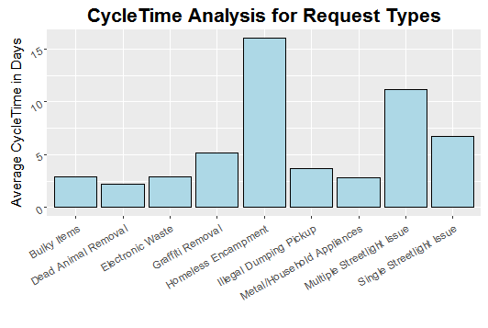

* Average CycleTime : 3.5 days, SD: 9.5 days
* A request can be serviced between 0 and 22 days with 95% CI
* Request Types with high CycleTime:
  + Homeless Encampment – 16 days
  + Streetlight issue ( Single: 7 days, Multiple: 11 days)

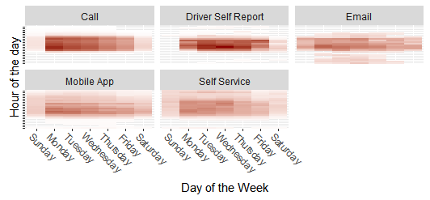

* Majority of requests are coming from call which covers more than 95 % of the dataset. Therefore in order to analyze other sources we needed to scale them.
* Majority of the requests coming through calls are coming from Mon-Wed 8 to 12 with peak in Monday morning
* Majority of the drivers self-report are made Tuesdays and Wednesdays mornings with peak on Wednesday morning
* Emails and Mobile App requests are spread across the week but still they are at peak on Monday morning

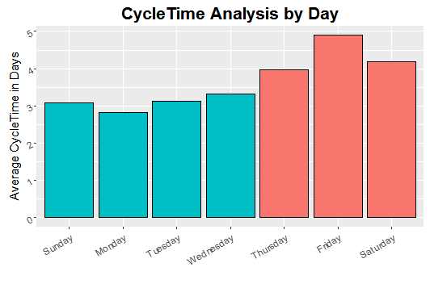

CycleTime is higher for Thursday – Saturday, as requests created on these days are affected by the upcoming weekend.

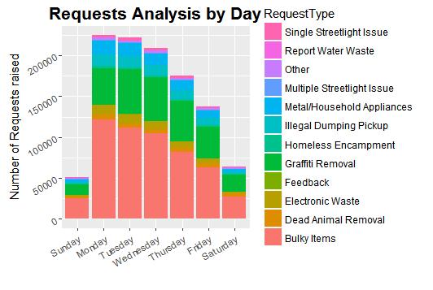

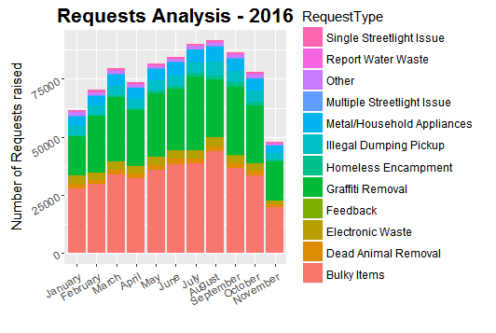

Cycle Time Prediction for the next 1 year

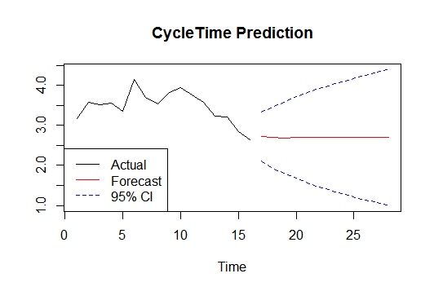

Number of Requests Prediction for the next 1 year

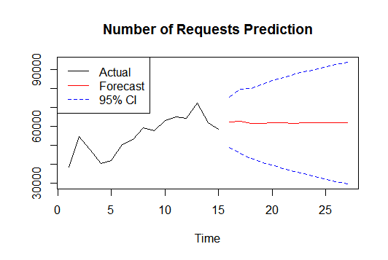



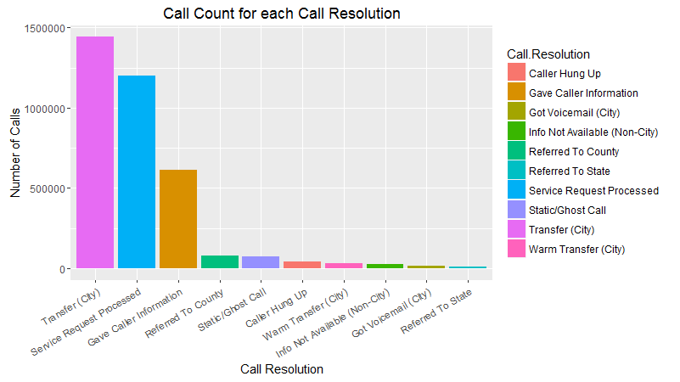

Distribution of call center calls based on Call Resolution:

* Call was transferred to other city for most of the call requests (40.7%)
* For around 34% of the calls, a Service Request was generated

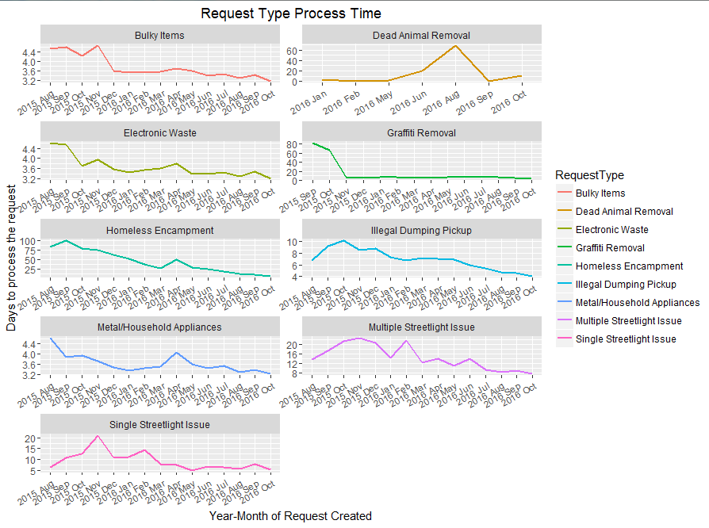

Trend in Process Time (defined as time taken to process the request) for each request type

For all request types, a decreasing trend in process time is observed indicating improvement in time taken to process a requestCheck requests that are made between midnight and

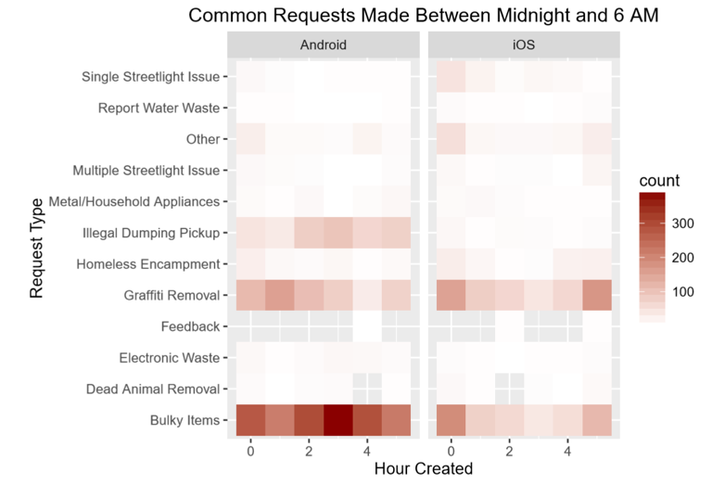

* 6AM:
  1. Most common requests made at night: Bulky Items followed by Graﬃti Removal.
  2. More requests are made from Android at night.
  3. Requests for Illegal dumping pickups are made only via Android at night.

1. Check mobile request source on both Mobile OS:

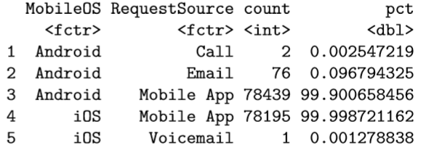

* 1. 99.9% of requests are made via the mobile app.
  2. The other sources are not enough to further explore…

1. Check Mobile Map usage in LA:

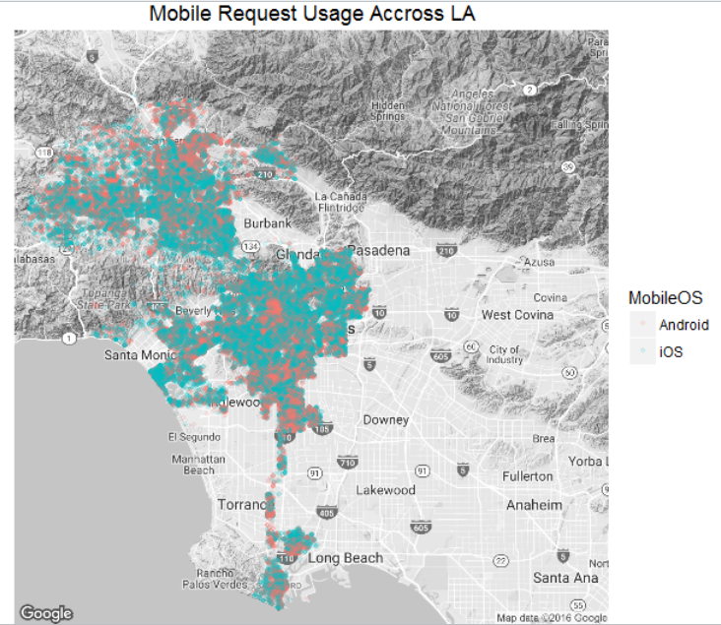

* 1. The distribution across LA seems to be fairly distributed among both OS
  2. Most calls are made in central LA area, Santa Monica, and the Valley.
  3. iOS seems to be more dominant on the map.

1. Check daily usage by Mobile OS on the LA map: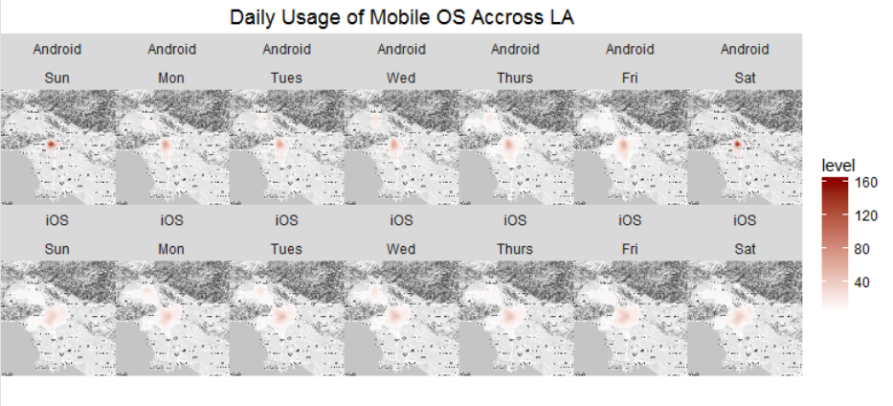
   1. Saturdays and Sundays in North Hollywood area seem to be the busiest for iOS.
   2. Not much can be told from Android.